**Week 3 Assignments**

Part – 3

**Decision tree classification with Titanic dataset**

Exploration of the data:

The data contains the details about the passengers who have travelled in the Titanic ship and mentioned who have survived and died in that disaster.

It contains the passenger details like ID, class, name, sex, age, sibsp, parch, ticket, fare, cabin, embarked and denoted 1 for the passenger who have survived and 0 for the passenger who have died.

It contains two datasets one is training and the other is testing

We will be creating the decision tree for the titanic training dataset based on the input parameters has the passenger details and the output parameters as the survival status and plotted using rpart library.

This survival prediction is compared with the titanic testing dataset through predict keyword and generated the output as 1’s and 0’s for the survival.

The decision tree is displayed below.

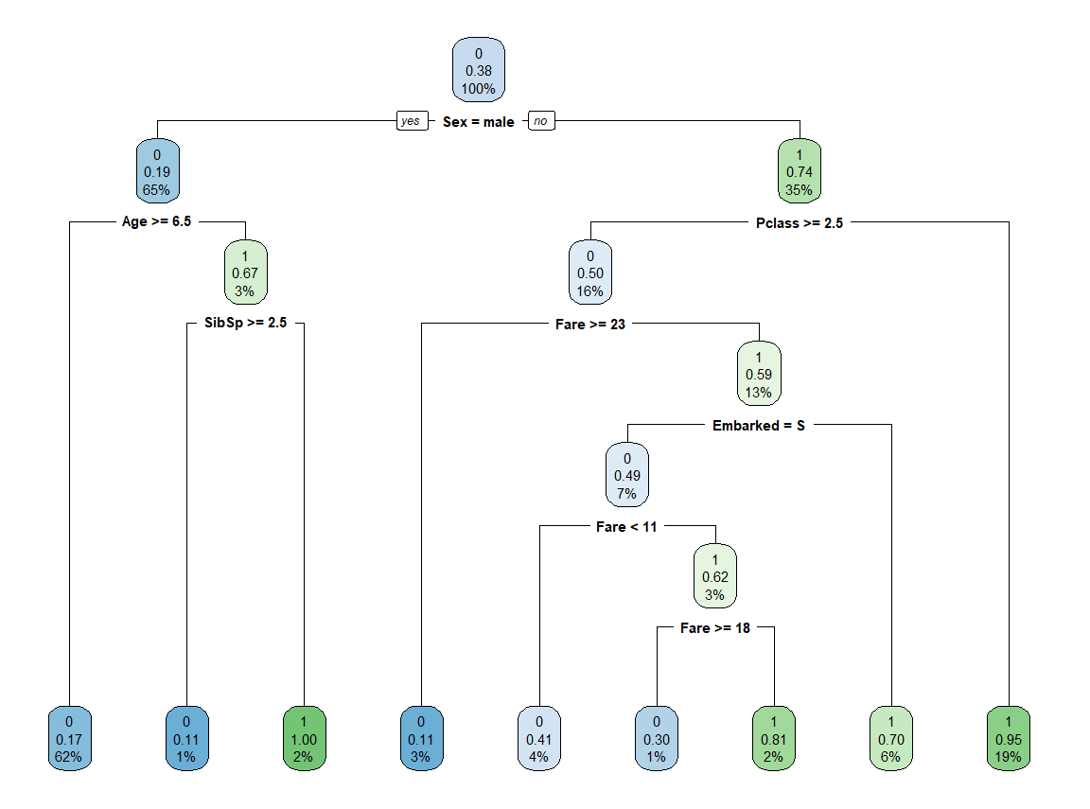

**Decision tree regression with Energy Efficient dataset**

Exploration of the data:

It is an energy analysis using 12 different building shapes simulated in Ecotect. The buildings differ with respect to the glazing area, the glazing area distribution, and the orientation, amongst other parameters. It simulates various settings as functions of the afore-mentioned characteristics to obtain 768 building shapes. The dataset comprises 768 samples and 8 features, aiming to predict two real valued responses. It can also be used as a multi-class classification problem if the response is rounded to the nearest integer.

The model is build using the data which has the input parameter as relative compactness, surface area, wall area, roof area, overall height, orientation, glazing area, glazing area distribution and the output parameter has Heating load and Cooling load.

It contains two output parameters. The model is built for output y1, and output y2 and output y1 & y2

The decision tree for the outputs are displayed below

Output y1

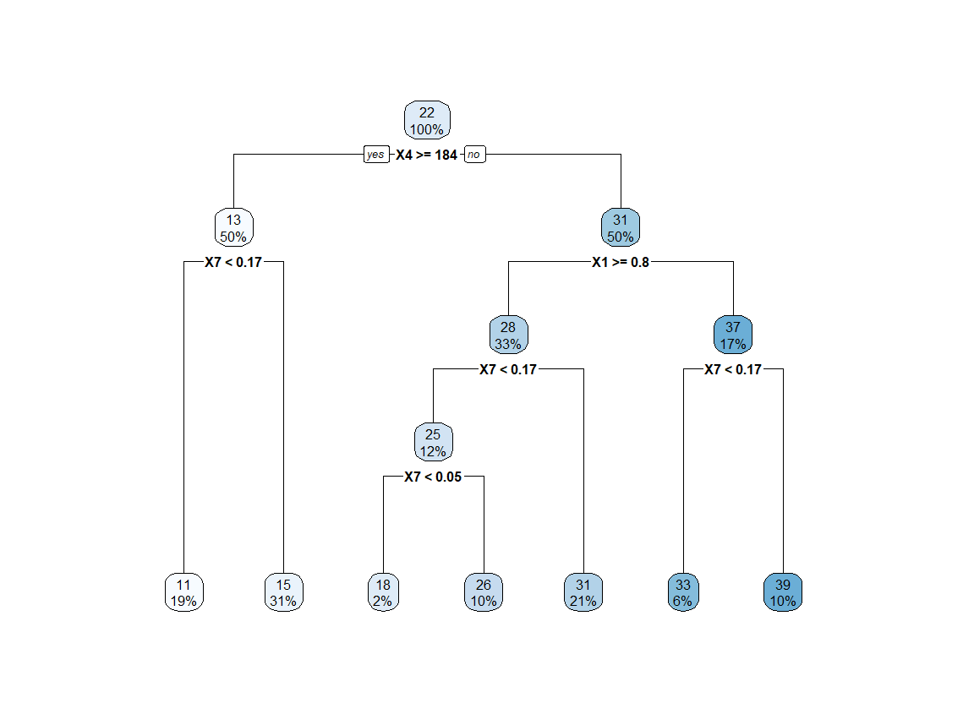

Output y2

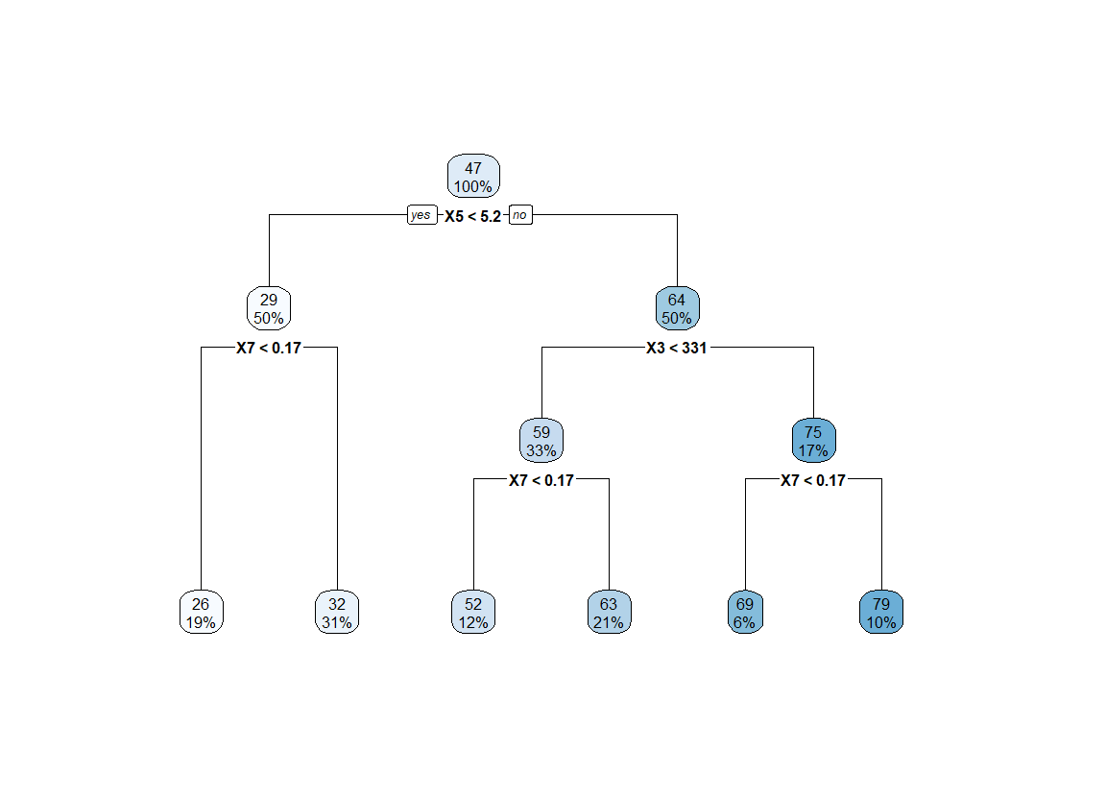

Output y1 and y2

